Mobile technologies and applications
Part 4

1. Today we will look at ways to optimize the Home screen page. To do this, we will need to import a special SafeAreaView component.

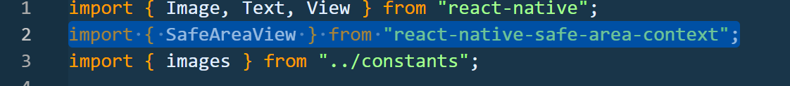

2. Next, instead of View, place SafeAreaView in your Home page. And launch the emulator.

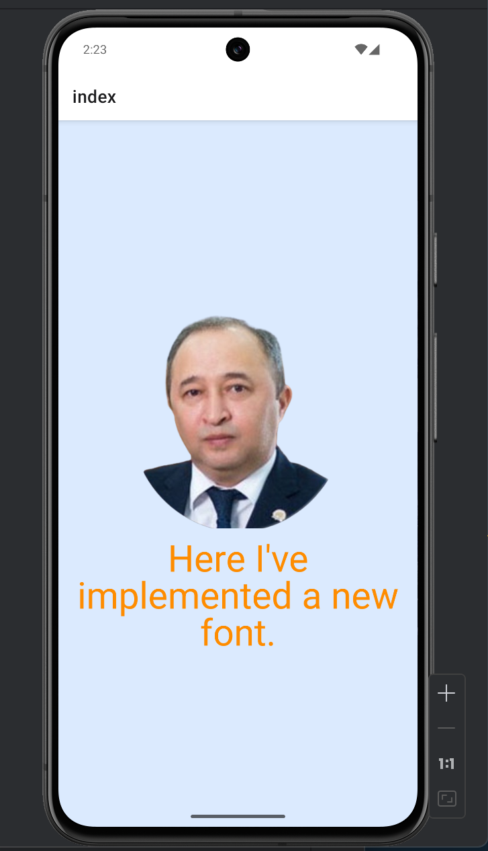

3. SafeAreaView allows you to arrange your content evenly within the screen without it going beyond the area.

4. Now let's get acquainted with the FlatList component , which allows you to efficiently display lists of data with high performance. Compared to the " map " method, which we use for similar purposes in React and Next.Js, it renders only those elements that are visible on the screen. It also automatically removes unnecessary elements as the screen scrolls. This is very effective for large lists.

5. Using FlatList , let's try accessing " offers " in constants. To do this, in FlatList define the data attribute and renderItem.

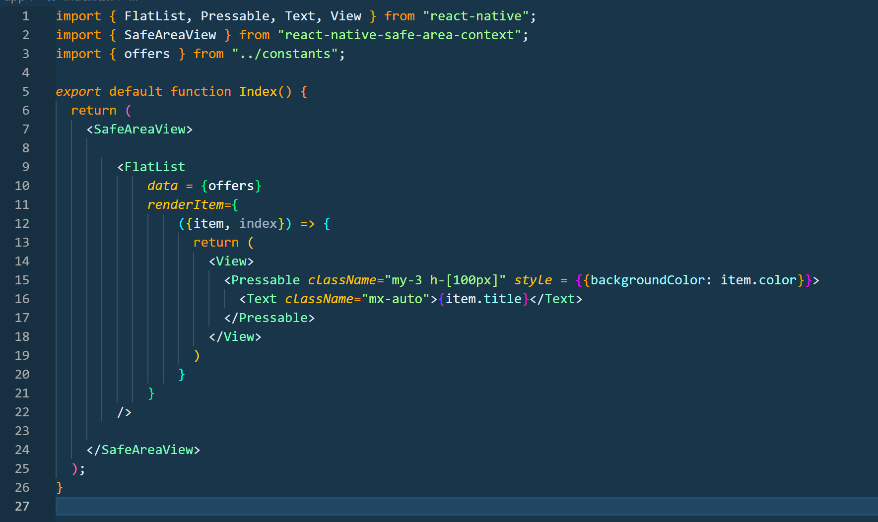

6. This code snippet uses the FlatList component to efficiently display a list of offers data by automatically creating UI elements for each array object, rendering only the elements that are visible on the screen, which positively impacts the app's performance. Each list item is generated using the renderItem function and represented as a Pressable component, which acts as an interactive container that responds to user clicks. The Pressable displays the text value item.title , and the background color is dynamically set using item.color, allowing for visual differentiation between list items .

7. Run the project in the emulator. If it doesn't work in the emulator, try running it in Expo. Go on your smartphone.

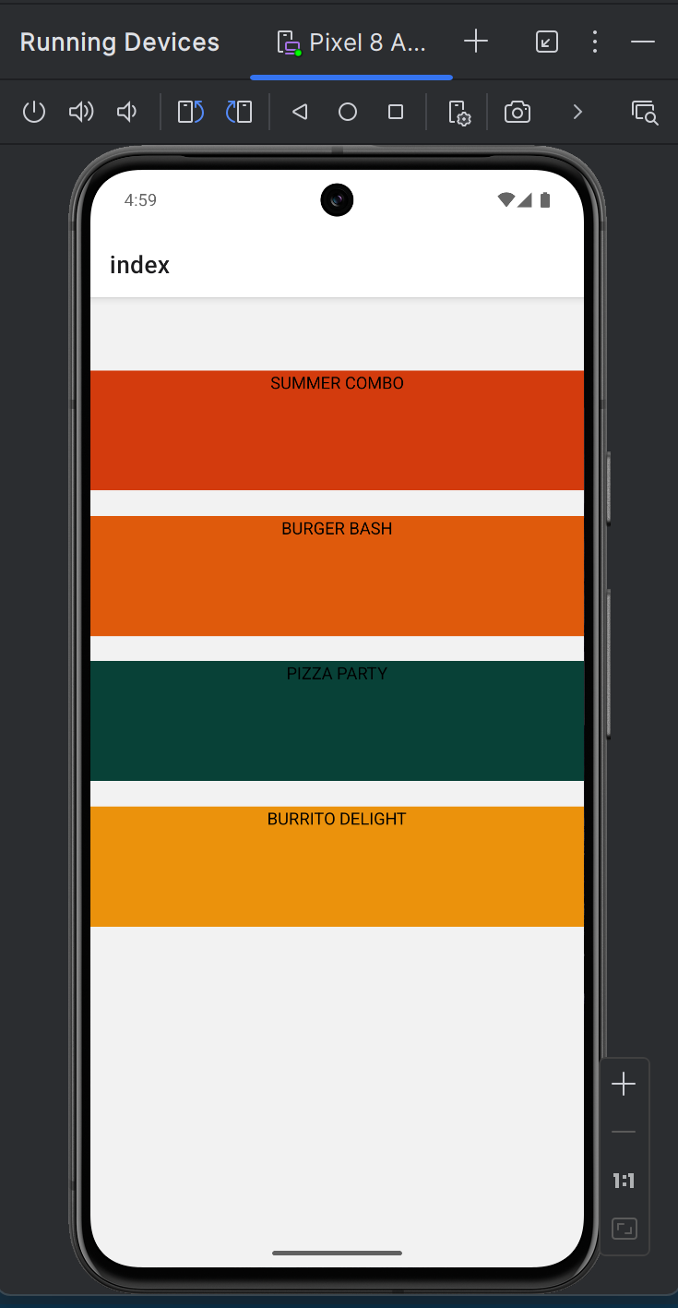

8. Now, especially for you, I am posting the styles as a set of layers in global.css.

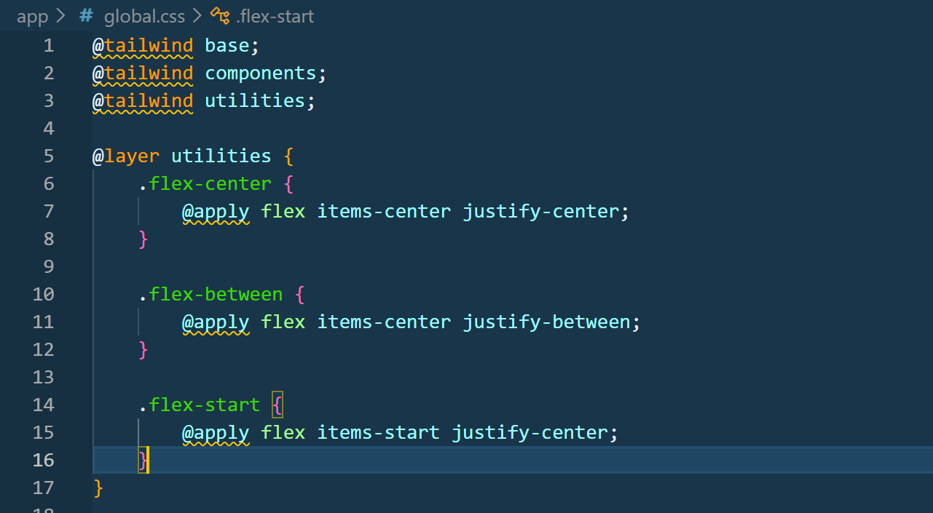

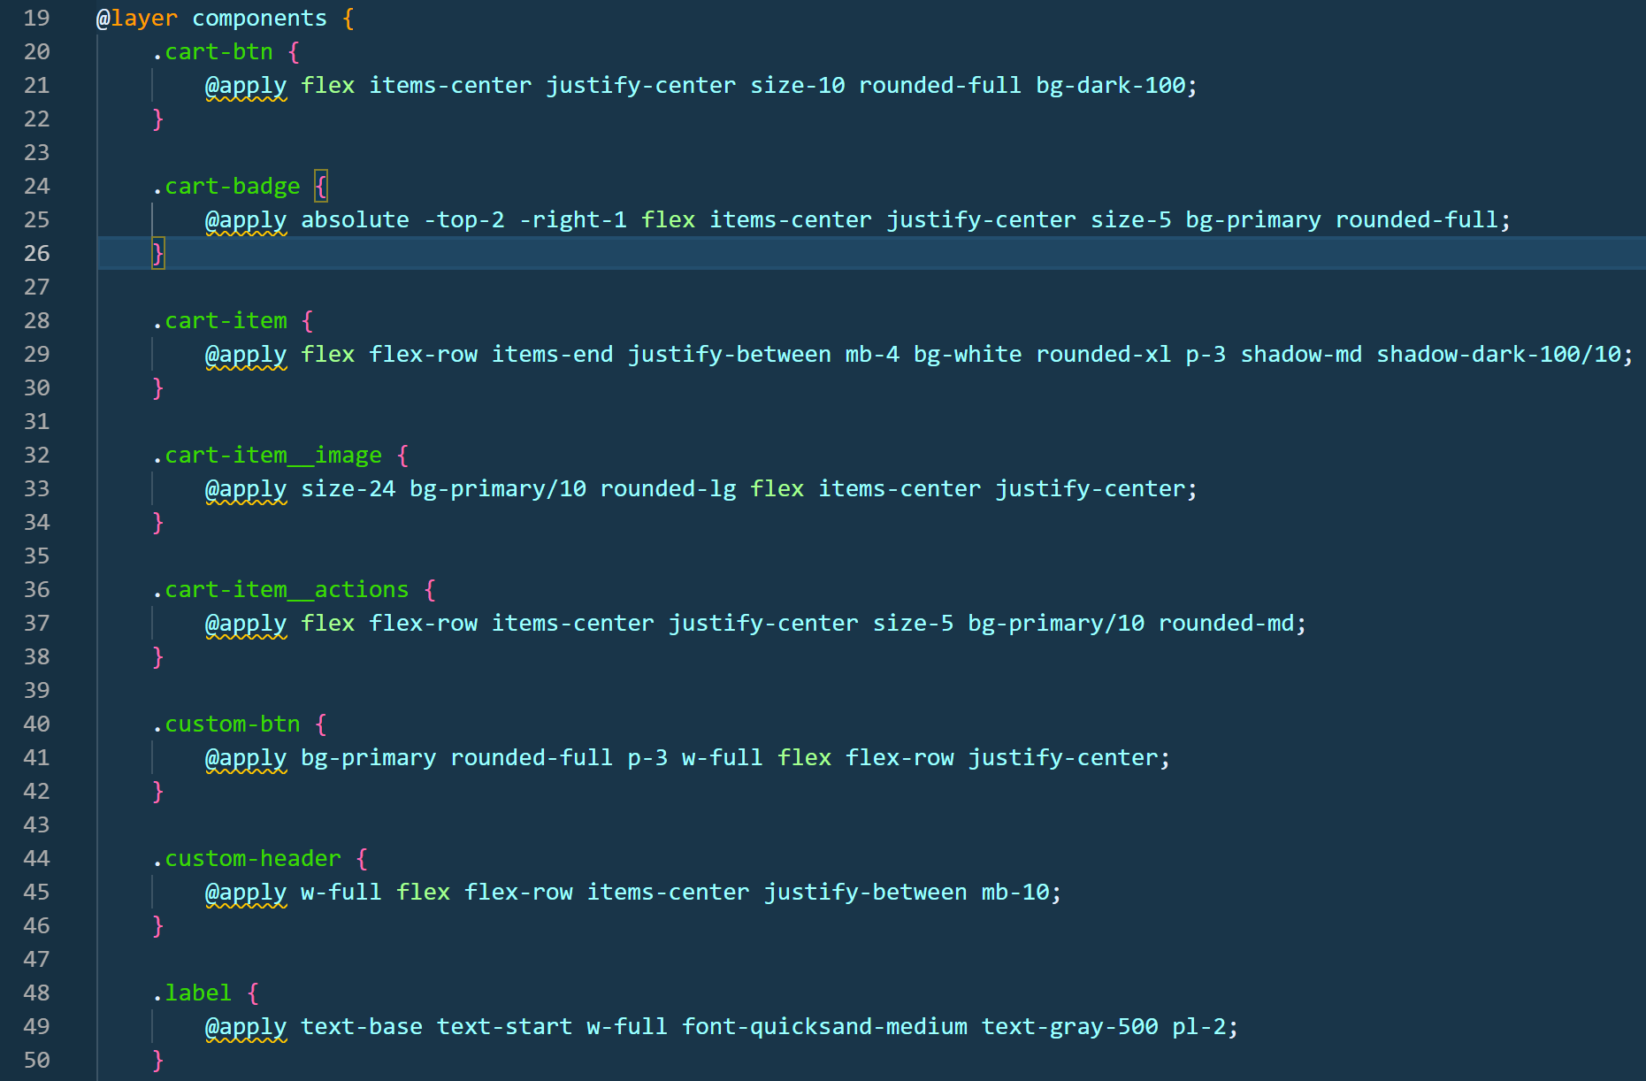

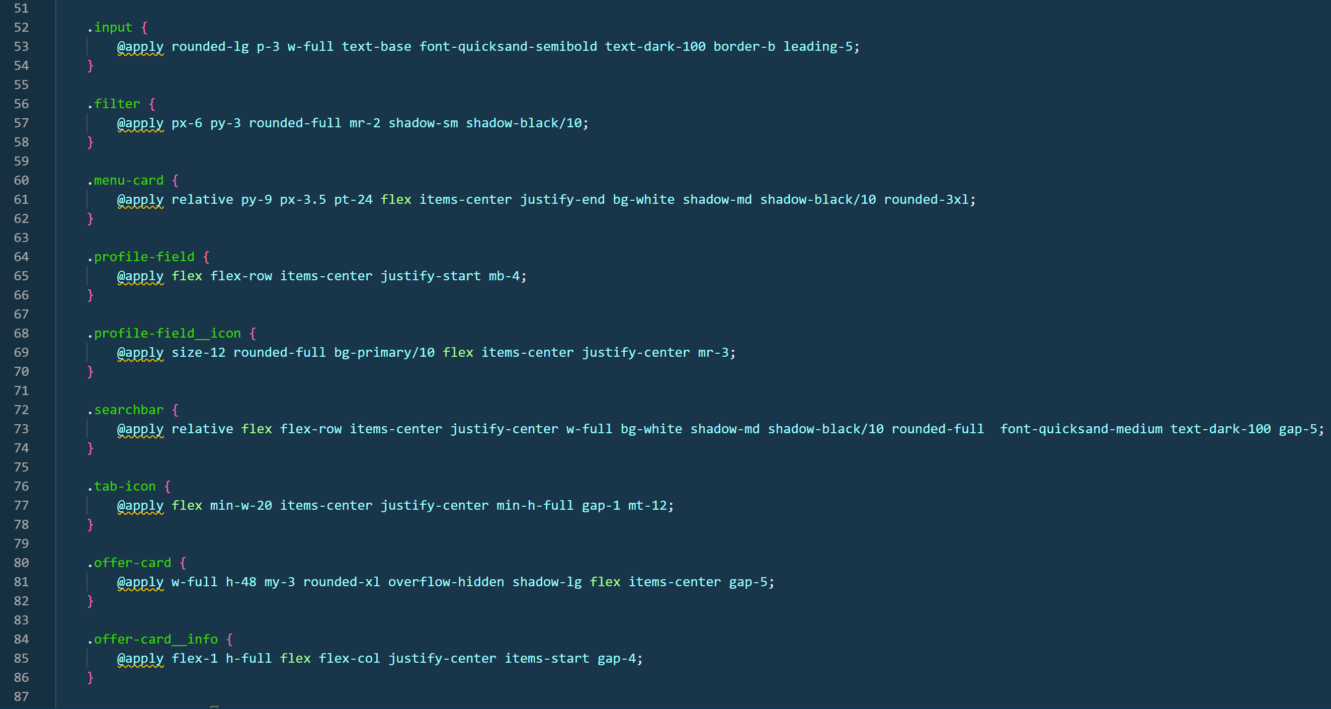

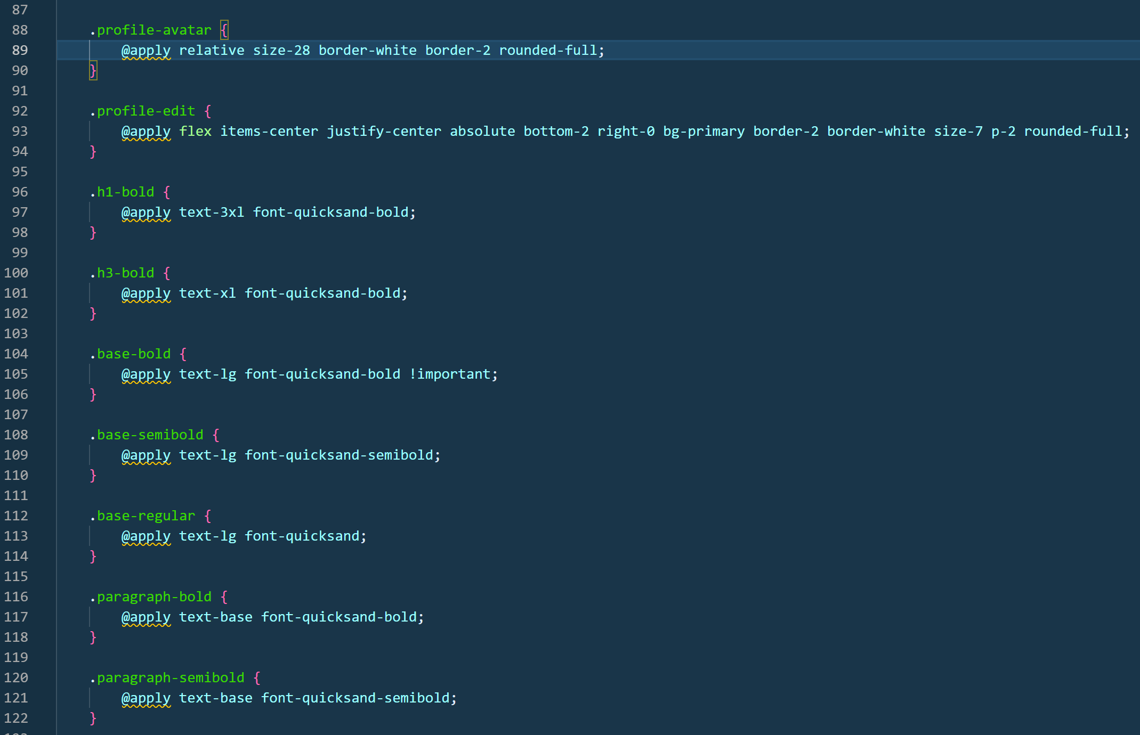

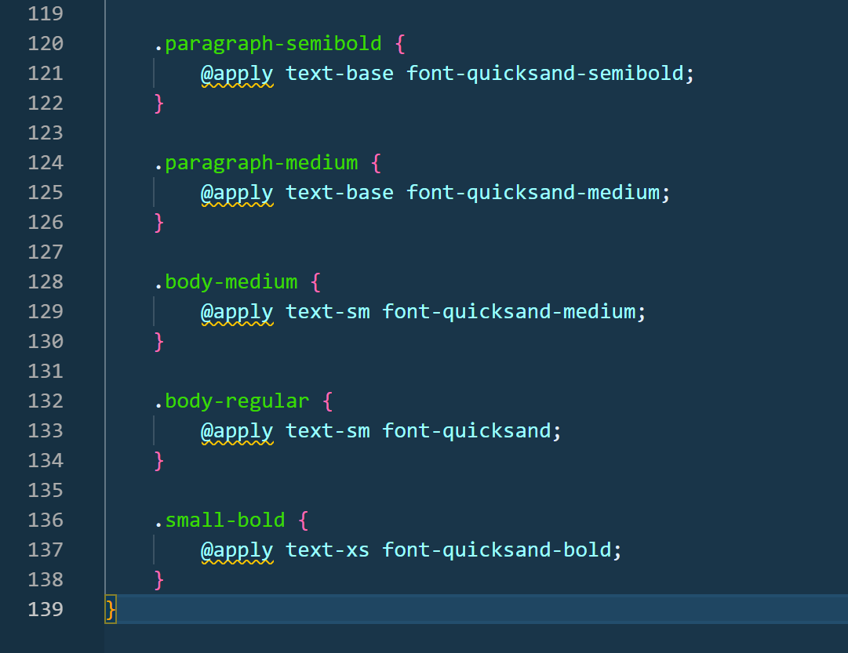

9. Now your global .css file uses the Tailwind layering mechanism CSS (@layer utilities and @layer components ) to extend the standard set of utilities and create reusable CSS classes that can then be included via className in components. The utilities layer declares simple helper classes, such as center-align or element-distribution, which essentially consolidate frequently used Tailwind utilities ( flex , items - center , justify - between ) into a single name. The components layer defines more complex, semantically meaningful UI classes—buttons, cards, profile fields, badges , headings, and typography —which are assembled from multiple Tailwind classes using the @apply directive . At build time , Tailwind unwraps these classes into regular CSS , adds them to the final stylesheet , and ensures correct priority through layers. This gives you a unified design language, reduces class duplication in JSX , and allows you to use short, readable names like offer - card , cart - item , or flex - center instead of long chains of utilities.

Pressable style code we can simply write “ offer - card ”.
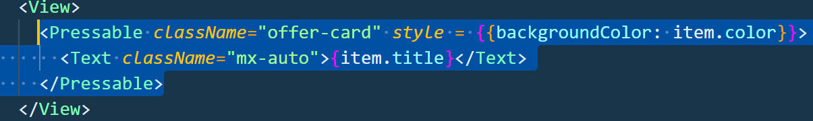
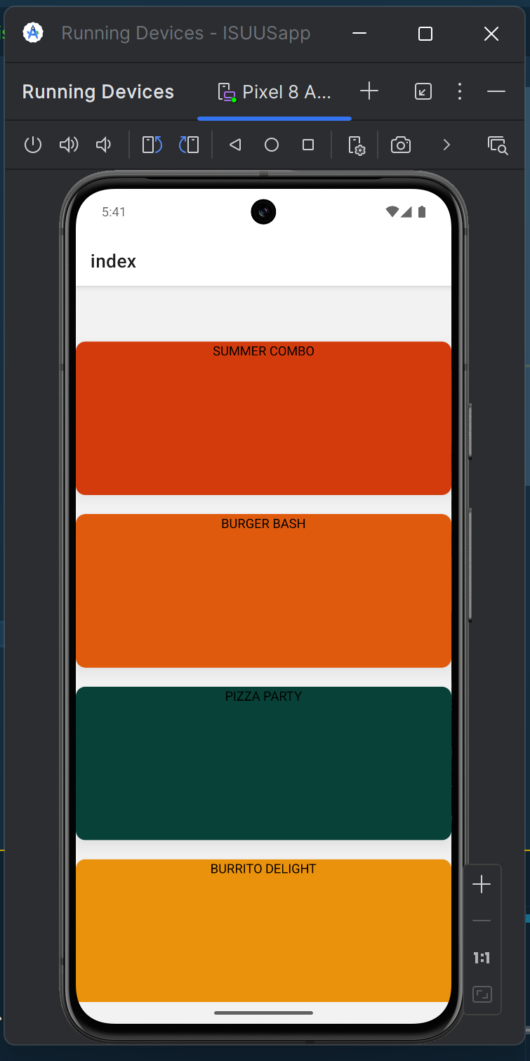

11. Now let's try working with the Pressed = True state . The rendering description is carried out inside the Fragment component .

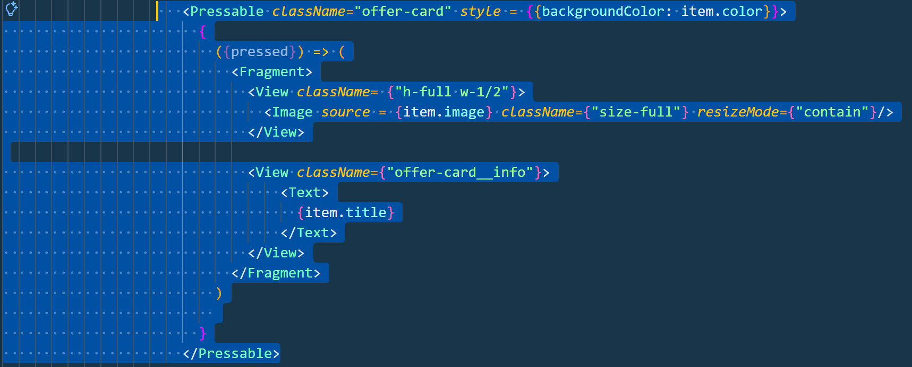

Pressable uses render-prop internally —instead of the usual JSX child elements, a function is passed that receives the pressed state object. This function takes the pressed parameter and is called again each time the user's interaction state with the card changes (pressed, held, released). This is why Pressable's content is formatted as ({ pressed }) => (...), rather than regular JSX.
The function returns a Fragment , which is only needed to group multiple root elements without adding an extra container to the view hierarchy. This is important in React. Native , because Pressable expects one return result, and logically there are two separate blocks inside.
The first View is responsible for the visual portion of the image card. It is assigned a class with a fixed height and half the card width, and an Image component is placed inside it . The image source is taken from item.image , that is, from the current list item's data. The size-full class stretches the image to fit the container, and resizeMode = " contain " ensures that the entire image fits within the container without being cropped or distorted.
The second View is the card's information block. It has its own style class and contains a Text component , which displays item.title . The value is passed in curly braces because it's a JavaScript expression, not a string. This way, the text is generated dynamically for each list item.

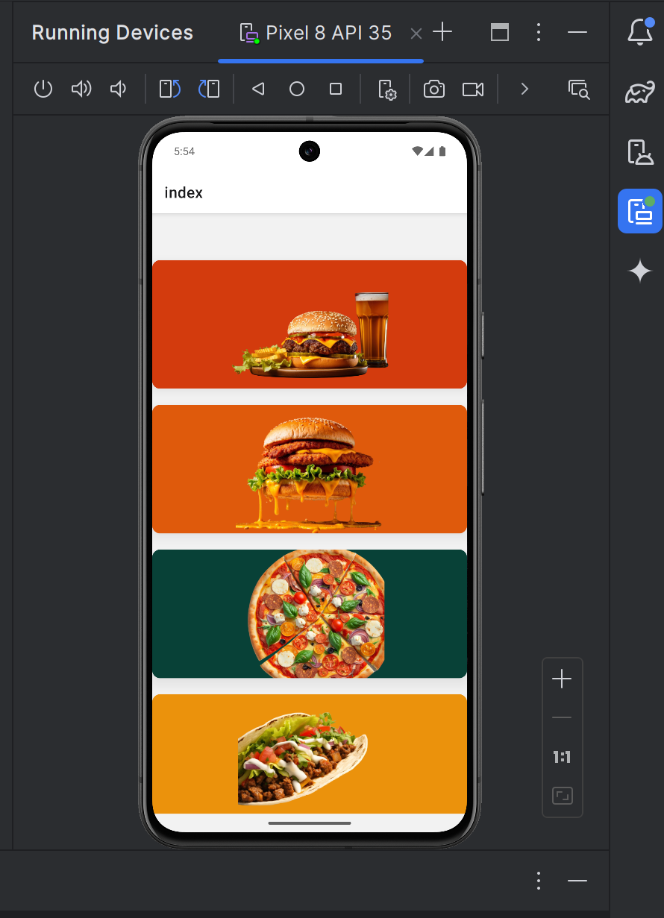

12. As a result, we see that our content doesn't place the text within the offer's visibility . To achieve this, we'll make the style dynamic and place the text to the left or right of the image. To do this, we need to install the clsx library via npm , which allows us to write conditions in styles. We'll also create an isEven constant to check for parity. This way, we'll implement the code so that the text is aligned with the image on odd-numbered cards, and on the right, on even-numbered cards.

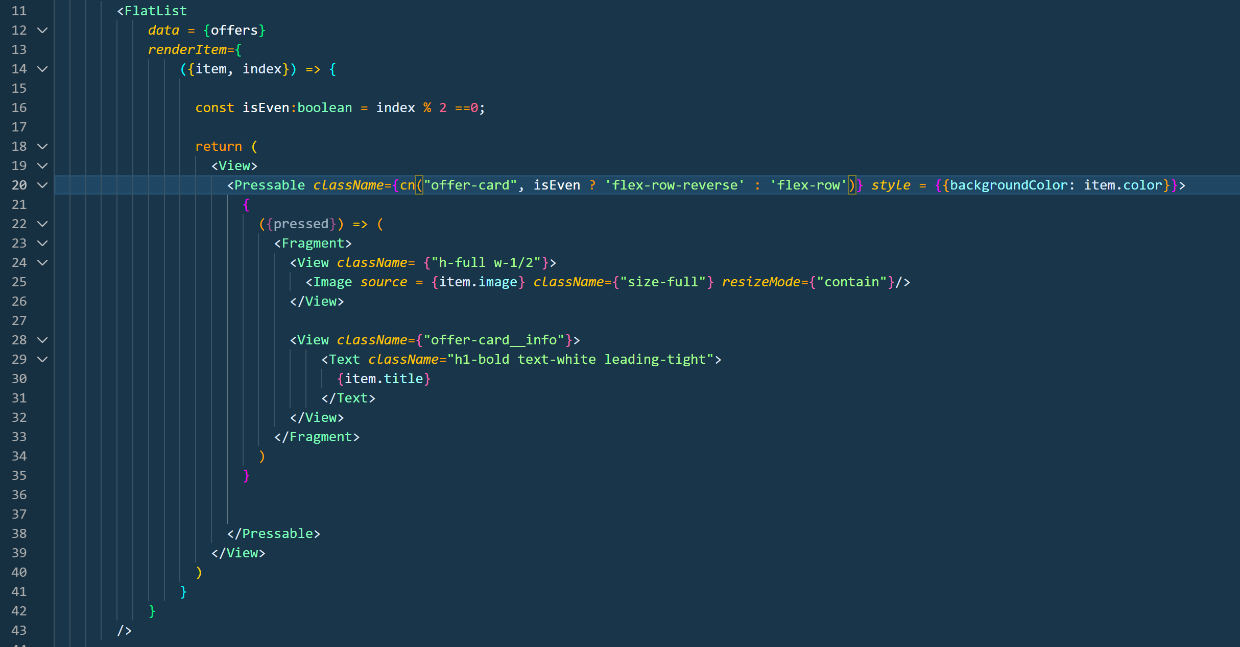

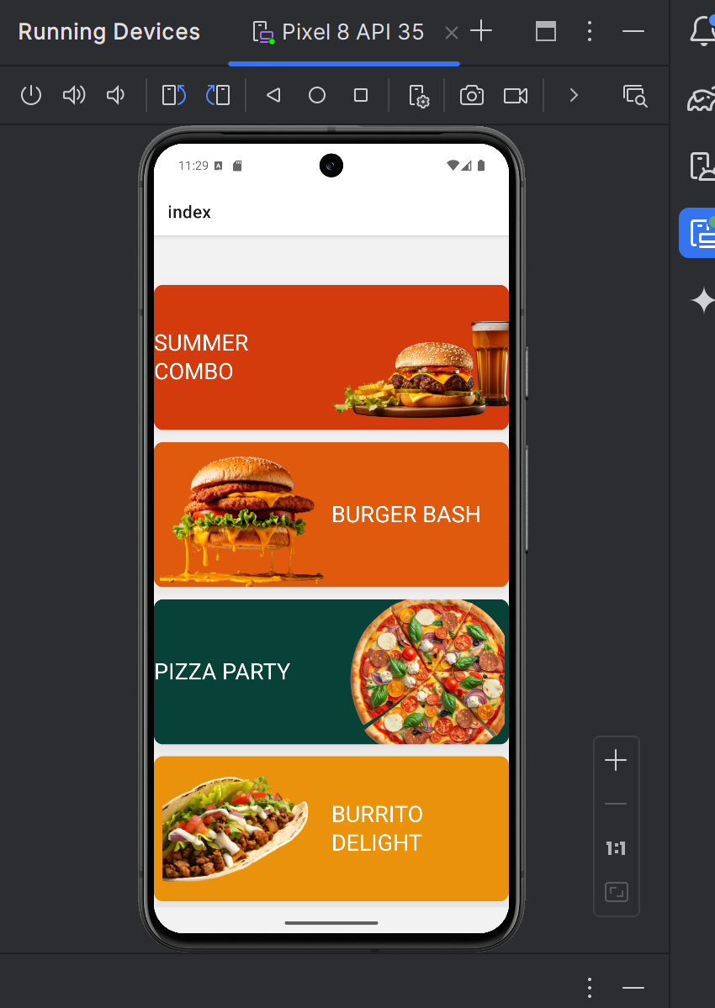

13 . Now let's optimize the display of offers.

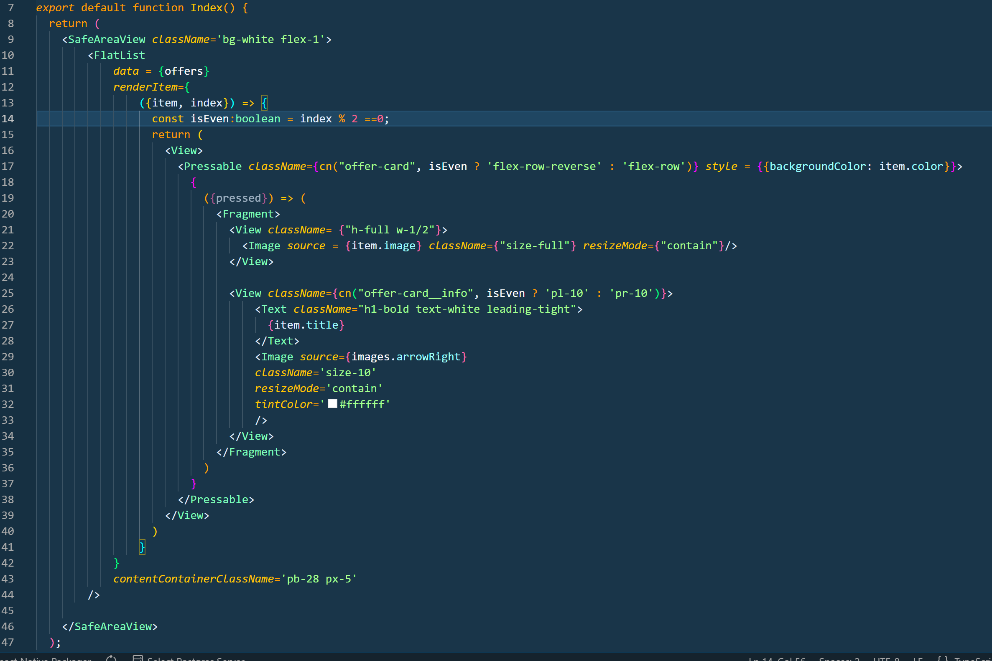

Arrows have also been added here for future routing.

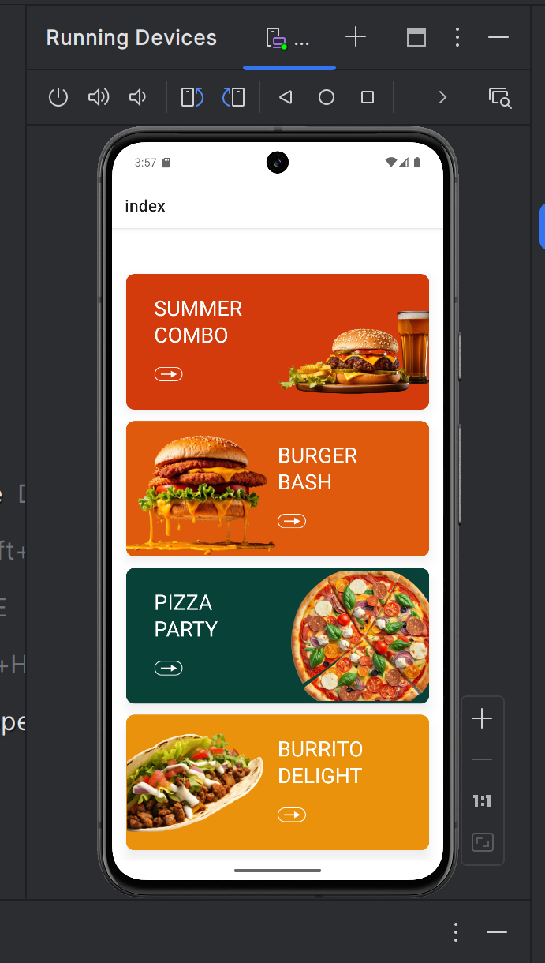

14. For the effect of pressing on the display, add the android_ripple property , setting any color for the wave divergence.
15. Now, using my example, create the headline of your application.

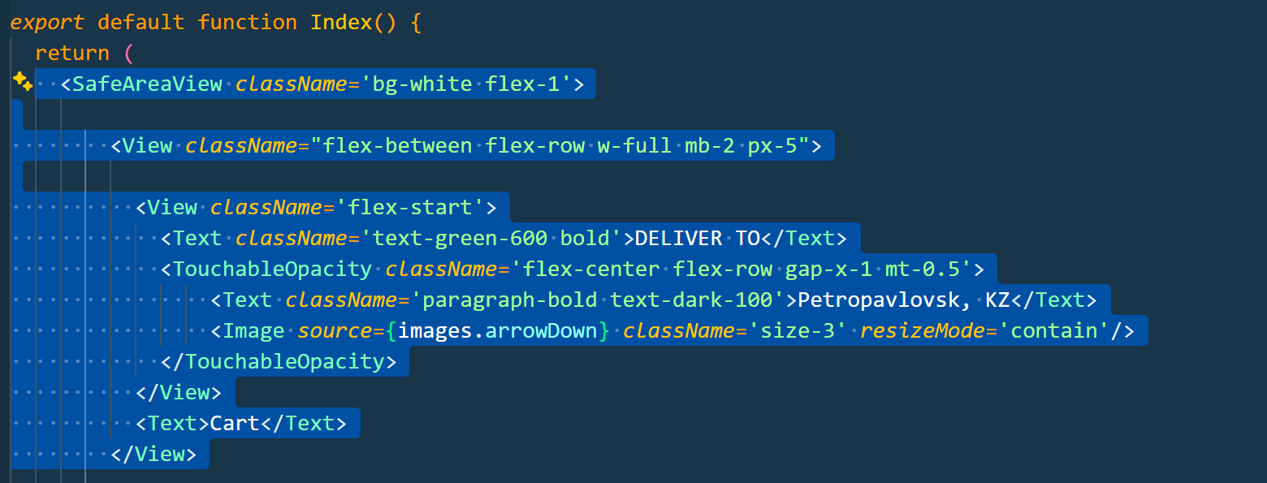

16. Also in React Native allows you to create your own components in the " components " folder . Let's create a "cartButton.tsx" component that will blink when you tap the cart.

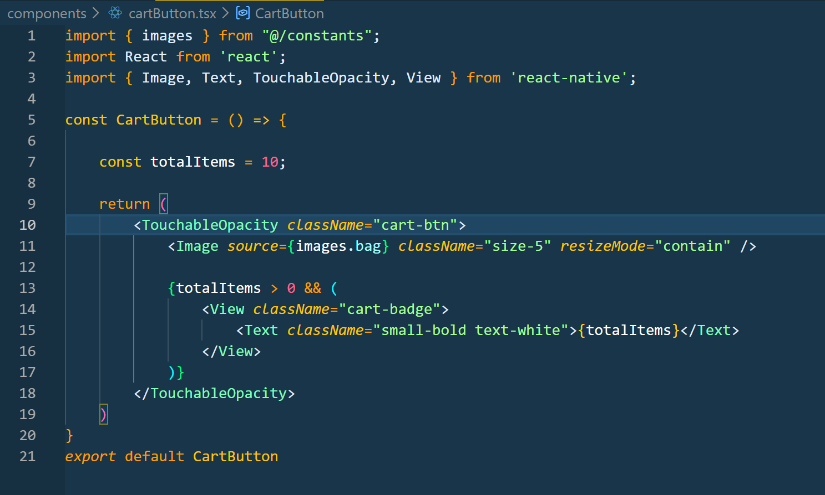

17. After this, instead of the text “ Cart ”, we introduce the CartButton component .

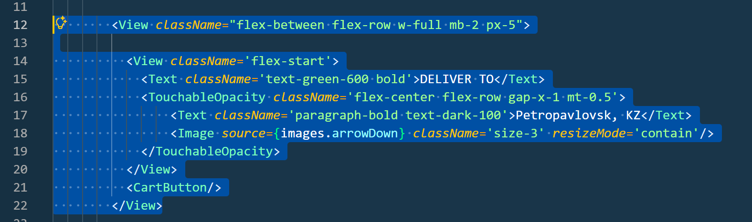
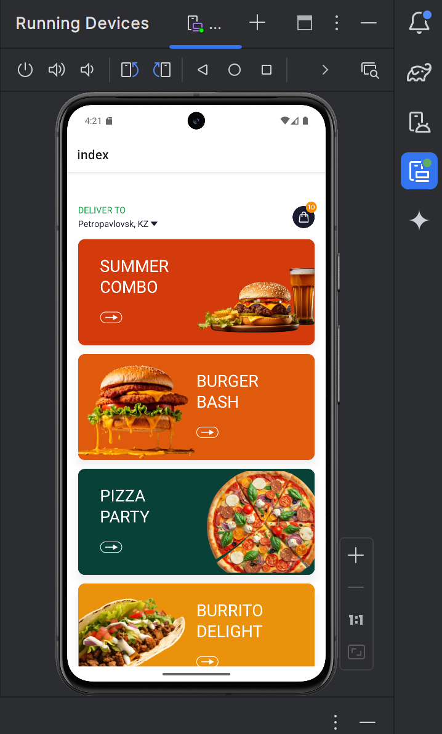

18. You can customize styles in the project. Create a progress report.

